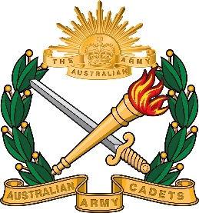 | New South Wales Australian Army Cadet Brigade  BAULKHAM HILLS HIGH SCHOOL CADET UNIT  419A Windsor Road Baulkham Hills NSW 2153  Ph: 9639 8699 Fax: 9639 4999  0413 283 150

BHHSACU/1/2018

23 August 2018

Dear Parents / Guardians.

Cadets cannot be picked up unaccompanied at school entrance at Caver Crescent.

This is due to some safety concerns and AAC duty of care issues.

Parent are either to pick up your son or daughter up from the School Bus Bay or PHYSICALLY come to the parade ground and accompany them back to your vehicle.

Should you have issues with this please contact myself directly.

C. Charlton
LEUTENANAT (AAC)
XO
0409 604 901

