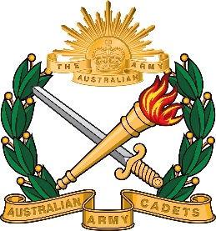 | New South Wales Australian Army Cadet Brigade  BAULKHAM HILLS HIGH SCHOOL CADET UNIT  419A Windsor Road Baulkham Hills NSW 2153  Ph: 9639 8699 Fax: 9639 4999

Discharge Check List

Items | Check
- Letter of resignation - Download the template from website
- Return of Items
  - Uniform
  - Field gear
  - Id cards/loan if applicable
- Complete the cadet unit deposit uniform form if applicable download from website. - Download form from website

Failing to complete the check list may result in no letter of reference from the school for your service in cadets.

